**Maternal mortality** – I have attached the updated data set – for some reason I gave you the wrong one. Other than that – I really like the layout of the dashboard.

# Done. updated data source and few tweaks.

# https://public.tableausoftware.com/views/MaternalMortalityUpdated/MaternalMortalityInTheTropics?:showVizHome=no#1

**Obesity** – Looks great. I wonder if we might be able to include the data for the rest of the world as well? I would be interested to see what that looks like. For the straddling nations – the data should be pretty much the same as it is a %...

# Done.The map is here

https://public.tableausoftware.com/views/ObsesityintheWorldMap/ObesityintheWorld?:showVizHome=no#1

New data sets:

**Female education ratio:**

Text: *Healthy and educated women benefit their family, community and nation. Educating girls has been shown to have huge benefits as it is associated with delayed marriage, lower fertility and improved health and survival rates for infants and children. Values for Australia, Brazil, Mexico, China, India, Bangladesh and Saudi Arabia represent only the tropical regions of those nations.*

Use the same dashboard as Obesity but do not include the rest of the world data at this point.

#DONE

https://public.tableausoftware.com/views/FemaleEducationRatio/FemaleEducationRatio?:showVizHome=no#1

**Adult mean years of schooling**

**Text:** *Education and literacy are key drivers of economic development, reflecting a nation’s stock of human capital. Education is also strongly correlated with health and wellbeing, and economic productivity of nations. Mean years of schooling is an indicator of the aggregate stock of human capital available in an economy and society, and is comparable across populations. Values for Australia, Brazil, Mexico, China, India, Bangladesh and Saudi Arabia represent only the tropical regions of those nations.*

This one should be fairly easy to illustrate as the numbers only range from 1 – 9. Not sure if different colours or different sized dots will work better? What do you think? Let’s just include tropical nations and regions at this point…with the rest of the world info available on the side graphs…

# Done.

https://public.tableausoftware.com/views/AdultMeanYearsofSchooling/MeanYearsofSchooling?:showVizHome=no#1

# Have been deleting blank entries with null values in this ZIP.

**Adult Literacy**

*Education and literacy are key drivers of economic development, reflecting a nation’s stock of human capital. Basic literacy and numeracy skills increase a person’s chances of finding paid employment and escaping poverty. In a rapidly changing, technology driven world, adult literacy is increasingly important. Values for Australia, Brazil, Mexico, China, India, Bangladesh and Saudi Arabia represent only the tropical regions of those nations.*

As this is a continuous rate, I think that a changing colour scale will be most effective. With the regions graphed on the side…

#Done

https://public.tableausoftware.com/views/AdultLiteracyRatio/AdultLiteracy?:showVizHome=no#1

**Youth Literacy**

*Education and literacy are key drivers of economic development, reflecting a nation’s stock of human capital. Basic literacy and numeracy skills increase a person’s chances of finding paid employment and escaping poverty. The youth literacy rate reflects the quality of basic education and its degree of inclusiveness. Values for Australia, Brazil, Mexico, China, India, Bangladesh and Saudi Arabia represent only the tropical regions of those nations.*

Same as Adult literacy

#Done

<https://public.tableausoftware.com/views/YouthLiteracy/YouthLiteracy?:showVizHome=no#1>

**Deaths from AIDS**

*AIDS has significantly affected human and economic development in many nations, claimed over 30 million lives, orphaned more than 16 million children and in the most affected nations, erased decades of progress in reducing mortality. It is much more prevalent in tropical nations, especially those in Central and Southern Africa. Values for Australia, Brazil, Mexico, China, India, Bangladesh and Saudi Arabia represent only the tropical regions of those nations.*

I think we should use the different sized circles for this one…the deaths peaked in the 90s and have declined…include graphs for the regions as well as for the tropics and rest of world. The vast majority of these deaths are in Central and Southern Africa so I am not sure what the best way to demonstrate that is?

#Done

<https://public.tableausoftware.com/views/AIDSDeaths/AIDSDeaths?:showVizHome=no#1>

# I’m not sure either – perhaps a story telling template will help out here – see the Startup image and story points for ideas.

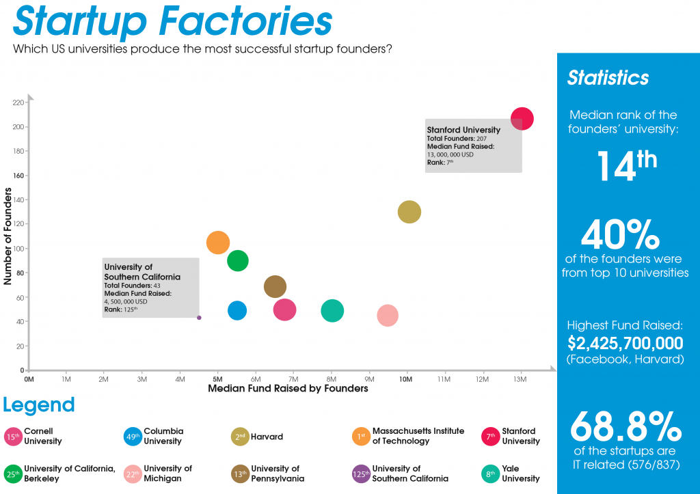

**Child (under 5) mortality rate**

*Young children are more susceptible to infectious diseases than adults and are especially vulnerable to environmental threats. Under-five mortality relates directly to child survival, reflecting the social, economic and environmental conditions in which children survive. Values for Australia, Brazil, Mexico, China, India, Bangladesh and Saudi Arabia represent only the tropical regions of those nations.*

Given the scope of numbers in this indicator, I think the different colours will work (although the time series is short)…also include regional graphs.

#Done

https://public.tableausoftware.com/views/ChildUnder5Deaths/ChildUnder5Mortality?:showVizHome=no#1

**Deaths from tuberculosis**

*Despite its long presence in human society and significant efforts to control it, tuberculosis is the second leading cause of death from infectious diseases worldwide (after HIV) and is a major public health problem. Values for Australia, Brazil, Mexico, China, India, Bangladesh and Saudi Arabia represent only the tropical regions of those nations.*

Same as deaths from AIDS

# Done

https://public.tableausoftware.com/views/Tuberculosis/Tuberculosis?:showVizHome=no#1

**Malaria**

*Malaria is a leading cause of death globally, particularly among children. Warm temperatures lead to more intense transmission and poverty results in higher mortality rates. This means that malaria is largely a tropical problem. Values for Australia, Brazil, Mexico, China, India, Bangladesh and Saudi Arabia represent only the tropical regions of those nations.*

We only have single data points for these data (2010) – no time series. So perhaps just a map with different colours to demonstrate prevalence (cases per 100,000 population) with a regional bar chart (rather than line) on the right.

**Undernourished population**

*Nutrition is a fundamental factor underlying health and wellbeing. A significant number of people in the Tropics do not have access to adequate food and water, leading to the occurrence of preventable diseases. Values for Australia, Brazil, Mexico, China, India, Bangladesh and Saudi Arabia represent only the tropical regions of those nations.*

Like all the other population indicators…different sized dots I think.

**Urban Population**

*A transition to urban living has been underway since industrialisation commenced. The growth of cities can have both positive and negative effects on economies, environments and wellbeing.**Values for Australia, Brazil, Mexico, China, India, Bangladesh and Saudi Arabia represent only the tropical regions of those nations.*

I think urbanisation will be best represented by the different sized dots with the associated graphs on the side. Not sure if % population or total numbers will show the biggest change?

**Slum population**

*Although urban social organisation can have beneficial consequences, urban slum dwellers often live in poverty without access to safe water, sanitation or security. Slums are an indicator of unsustainable urbanisation and inequality. Values for Australia, Brazil, Mexico, China, India, Bangladesh and Saudi Arabia represent only the tropical regions of those nations.*

The most complete data is those from 2001 but like malaria we only have that one year of data. So a map with different sized dots and accompanying bar chart is probably the best.